<https://www.cambly.com/api/chats/62f8f19cc7530c89efd32f17/video>

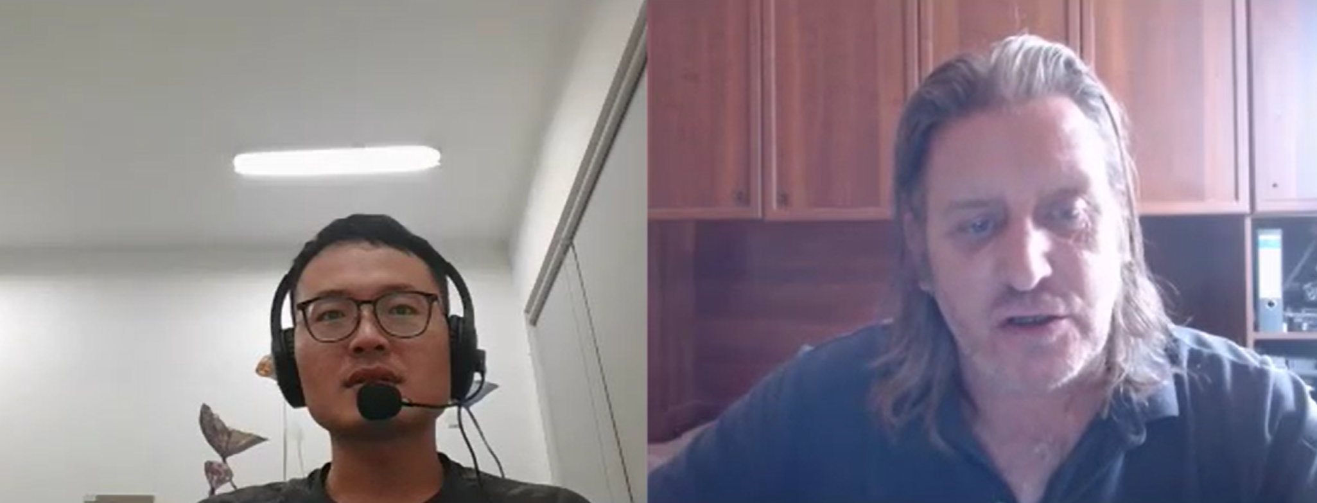

|  |  |  |  |
| --- | --- | --- | --- |
| We will  We’ll | Used d  Looked t  Wanted id | get-together  party |  |
| These theez | Leisure /ˈleʒə(r)/ |  |  |
| Between  Be tween | Isolated /ˈaɪsəleɪtɪd/ |  |  |

Beauty is in the eye of the beholder

beauty is in the eye of the beholder //情人眼里出西施wanted

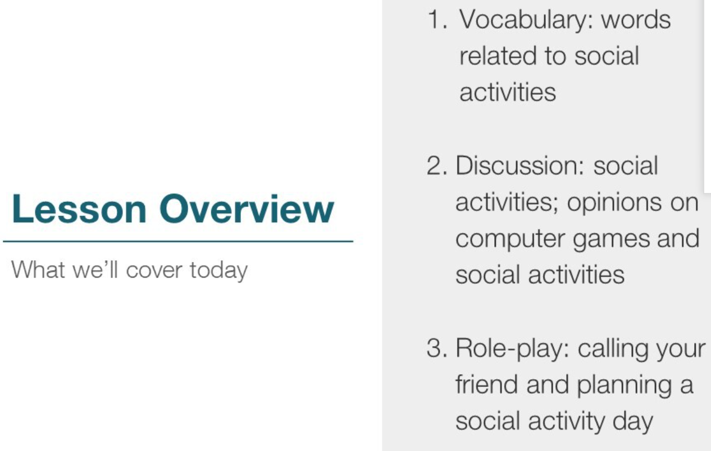

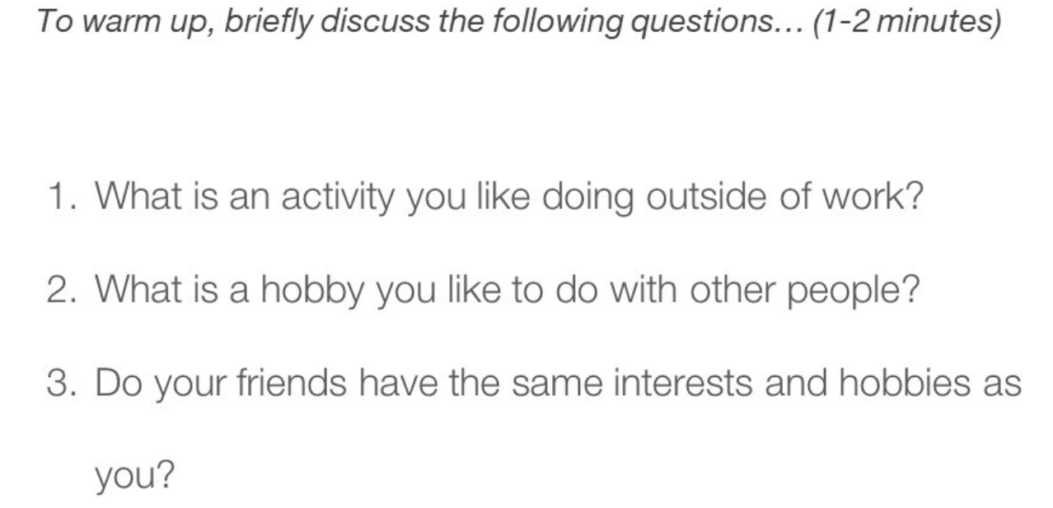

1 The activity I like doing outside of work is playing basketball because it can relax my pressure.

1. The hobby I like to do with other people is playing basketball because it can relax our stress and enrich our relationship.

3.Most of my friends have the same interests and hobbies as me, such as play basketball because we like physical activities.

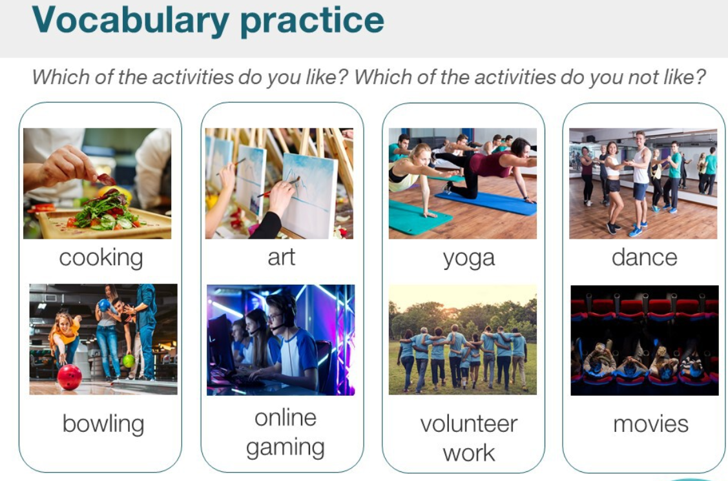

The activities I like are cooking and volunteer work. However, I don’t like the online gaming and art.

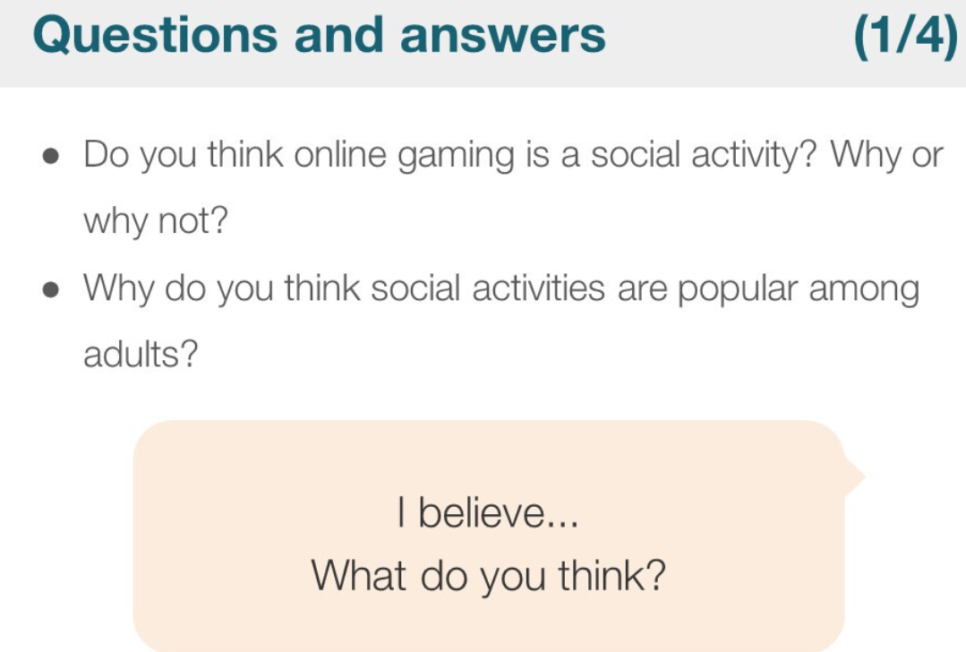

1 I believe the online gaming is a social activity because we can chat with other players.

2 In my opinion, I think the social activities are popular among adults because they can escape from the daily stress.

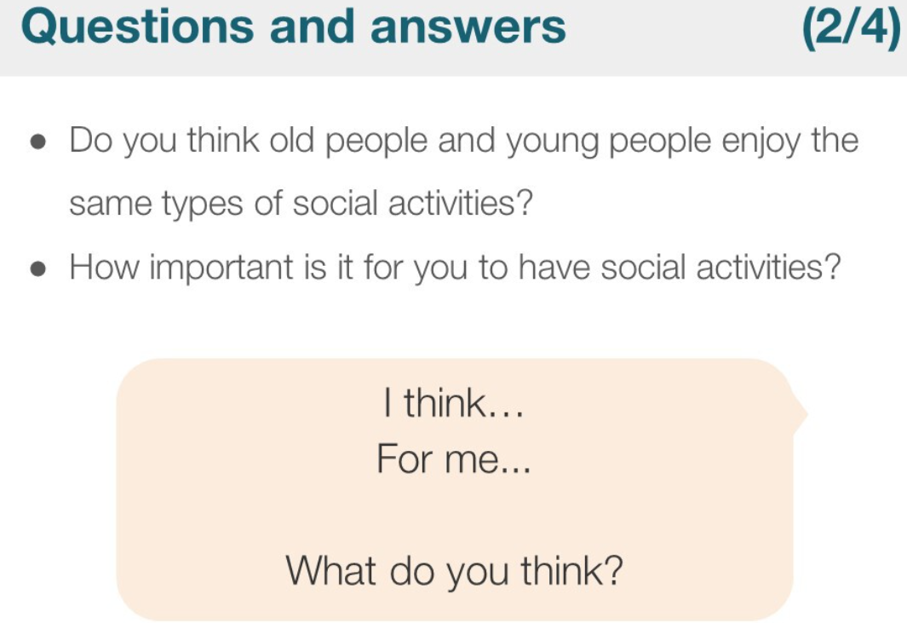

(1) In my opinion, I think old people and young people not enjoy the same types of social activities. Because the young like the physical activities, however, the old like the relaxing activities.

(2) In my opinion, the social activities are important because it can escape people from daily stress, most time, it can enrich the friendship with friends.

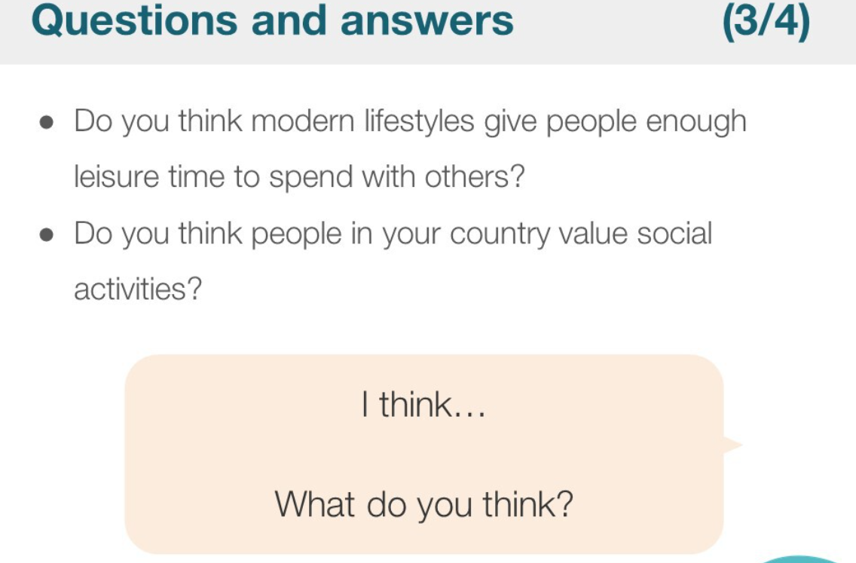

1. In my opinion, I think the modern lifestyles not give people enough leisure time to spend with others. Because work hours are too long.
2. I think people in our country, they are interested in social activities because it can escape them from daily stress. / relax their work pressure.

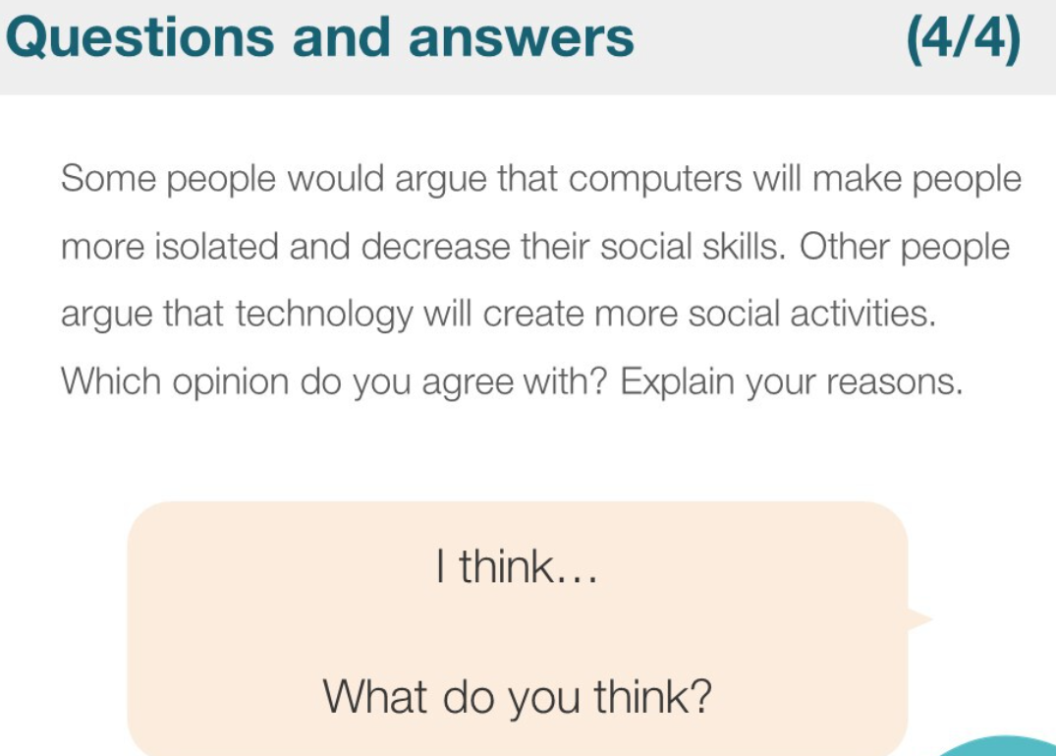

In my opinion, I support he above opinion that computers will make people more isolated and decrease their social skills. Because the surfing the Internet increase spaces between people and people. In addition, people have less opportunity to face to face to do something, that can decrease their social skills.

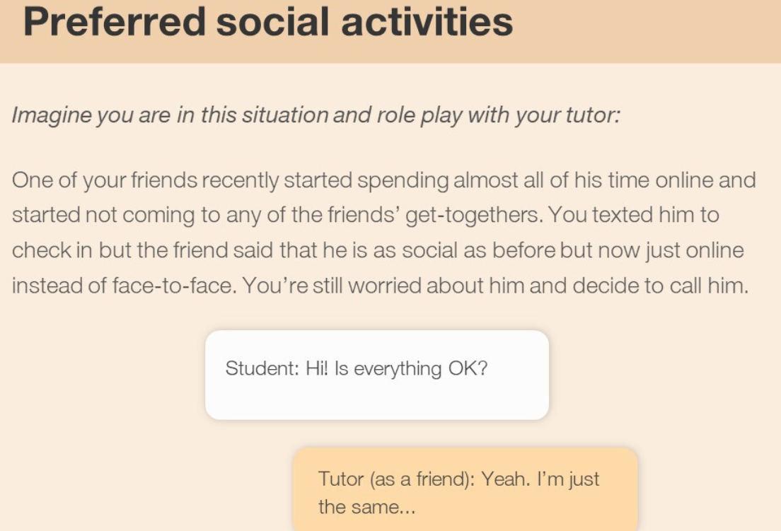

get-together